**Level 2 – How**

**How do we do, what we do?**

In level 2 we are focusing on execution i.e., delivery or outcomes of services or product. The success of the execution is based on the performance. Whoever does the execution the result should be similar. This ideally depends on 3 factors consistent, repeatable, predictable.

iPrimed is a predominant training transformation company and it is a service-based company. In our company students and clients are customer. Here customer satisfaction is more important factor. iPrimed has two - three different kind of training. One is retail model which means we will train the students based on the course they preferred and they pay for it. We organise interview for them with few of our client companies. Other is HTT (Hire Train Transfer) model – people will join the iPrimed as interns and transfer to companies and HTD (Hire Train Deploy) model – Based on the industry requirements we will evaluate and train the learners and deploy them.

For example: The result of execution of iPrimed training company will be successful depends upon the performance of the trainers. There are different trainers for training the learners, the result should be similar outcomes. It is possible if we are following consistent, repeatable and predictable process. This leads to customer satisfaction. Make sure that the result is consistent, repeatable and predictable means it’s not necessary that every time we will have good candidates sometimes, we will not get good candidates. Here the quality of input also varies irrespective of customer we have to provide the similar outcomes. So, in these cases we have to think in different perceptive way. Create everything in a systematic way and can execute with similar outcomes.

If the outcome is not similar then it will lose reputation, inconsistency among learners, dissatisfied clients and loss in business these are impacts.

To achieve the similar outcomes, we have to follow rules and regulations of the industry. These rules and regulations are based on couple of assumptions:

* Whom are you doing the service? – Doing for client. You need to clear about client expectations.
* Scope of the learning (What is included and What is not included)
* Since it is a virtual learning platform focus more on hands on practice so that the learners will not lose the interest.

For these things to execute we need to defined a process. For Example: M C Donald’s French fries. Where ever we go. We order French fries and we have the same taste. This is possible with the help of consistent, repeatable and predictable of the industry. To define these, we have guiding principles. Guiding Principles are like principles which are followed in different religions i.e., Quran, Bible etc.

iPrimed have some guiding principles:

**Blending/Integrated Learning**

Blended means different channels of delivery i.e., face to face, online platforms, mixing virtual and real medium. In iPrimed the blended learning means blending skills in learning sessions.

Two kinds of Skill buckets:

1. Content Skills
2. Core Skills

**Content Skills**

Content Skills are tangible i.e., touch and feel

3. Domain

2.Process

1.Direct

1. **Direct Skills**

Direct Skills are something that are directly go and work in a company. It’s a functional skill of a learner. For e.g., Java full stack. We can call this as professionals.

1. **Process Skill**

Process Skill is based on two aspects i.e., method and systematic. These aspects will lead to a similar outcome with consistent, repeatable and predictable process. Thus, making professional to enter into domain skill.

1. **Domain Skill**

It’s an order management. The industry like telecom industry or banking industry the requirements of candidates will be different. Each learner’s will be allocating a domain based on their functional skill and they have to undergo different levels of stages based on their domain area.

**Core Skill**

Core Skills is divided into Communication Skills and Behavioural Skills. Again, divided into Explicit and Tacit Skills.

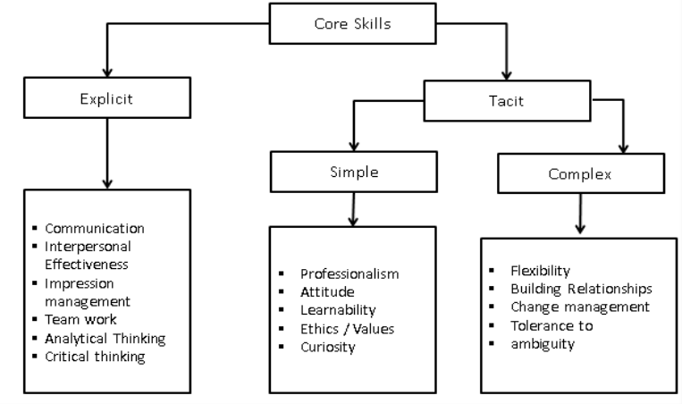

**Explicit Skills**

Explicit Skills are easy to understand and easy to change. The shortage of skills can be easily identified explicitly.

For e.g.: If a person is not good in communication and you are saying that you have to change it. They will able to understand and he/she has desire to change it. This will happen in a short period of time. This is what explicit skills. Make sure that each individual should know to read, write and speak.

**Tacit Skills**

Most knowledge are tacit that means you may know the things but not able to deliver it properly. It’s of 2 types Simple tacit and complex tacit.

1. **Simple tacit**

Simple tacit means easy to understand but difficult to change. There are few things that are easy to understand but difficult to change it will take time.

1. **Complex tacit**

Complex tacit means difficult to understand and difficult to change. There are few things which are really difficult to understand and difficult to change. For example: Suppose if we are saying a person to work on building a good relationship. In this scenario it is difficult to understand and difficult to change it purely depends on one’s interest.

How does this blending happen?

This blending is happened on basis of two level i.e., conscious and sub-conscious level. In conscious level we have dominant skills that is communication and in sub-conscious level we have to figure out different skills like relationship, ambiguity, professionalism, interpersonal etc.

For the effective and efficient outcomes, we need minimum 5-6 skills to be played at a given period of time. So, transition is occurred from one level to another level.

**Pull based Learning**

Pull based learning is a technique where the learner pulls the information from the facilitator rather than the facilitator pushing information into the learner. We focus on the strength of the learner in this approach.

There are 2 core factors – AIBC and Familiar to Unfamiliar

**AIBC (Awareness -Involvement-Buy in- Commitment approach)**

In the conservative method of teaching, we straight away get into the topic without even thinking whether the learner is aware about the topic or not. As per this guiding principle, the learner has to go through some stages which will ensure the learning curve keeps moving up.

**1) Awareness**

This stage is to generate awareness. Awareness can be generated by asking the right kind of questions relating to the topics. We make the aware of the issue by modifying their experiences.

**2) Involvement**

The learner starts applying the concepts that have been facilitated. Facilitator gives them feedback to correct their mistakes, this continues till they get the concept right. We make them involve in the concept by giving them exercise.

**3) Buy in**

In this learner understands and accepts the concept & realizes its important. Therefore, they start to apply the concept continuously without the facilitator pushing them.

**4) Commitment**

The learner adopts the concept and therefore uses its automatically whenever required. This can be noticed when a learner will apply this in their workplace. They become determinedly competent.

**Familiar to Unfamiliar**

This is a concept where the facilitator introduces a new concept by getting into their known world and then connecting the same with their unknown world. This factor of pull based learning uses the familiar experiences of the learner to understand an unknown concept which they would have already gone through in their lives. Just that they do not have a name to that experience that they have gone through. The External Factors are: Infrastructure: The seating arrangements are designed like a workplace. Everything has been modelled around the corporate world. No books/handouts: The learners need to pull the information from the people around & the internet.

**Young Adult Learning:**

Developmental point of view -Identity – Intimacy divide

The core of young adult learning consists of Identity and Intimacy and Experience Modification.

Young adults are people who fall within the age limit of 20-25 years. iPRIMED are dealing with an age group of 21 to 24 years. There are lot of physiological changes that a boy or a girl goes through while growing up. There is a crisis of Identity in our life. You are realizing who are you by the age of 18 or 19 which comes under adolescent. These group of people have inability to connect with opposite gender, inability to connect with parent and have pressure to perform. They are force to do the things.

As you move on from adolescent onto adult hood there are different issues you face, you get married, get into relations with the mother-in-law, father-in-law and after marriage there we will find changes in relations. The issue is that of intimacy.

**Deep Practice:**

**Why do we need deep practice?**

* Patience level of learners is short
* Insistence to become employable. More focus on jobs rather than building skills for a sustainable long-term career.
* Companies also want quick results in skills development.
* Shorter period of training is good for iPRIMED from a cost viewpoint.

According to a research,6 minutes of deep practice equals 1 month of regular practice. By practicing this guideline principle, iPRIMED aims to gain efficacy.

Efficacy

Duration

(1-1.5 months)

Duration

((2-3 months)

Efficacy

The duration (1-1.5 months) will make everyone happy and iPRIMED was successful with this setup. This is the objective of iPRIMED.

**What is deep practice?**

* Continuing to learn and practice at the edge of your abilities, one step at a time.
* Some of noticeable qualities of deep practice are:
  + Frustrating experience
  + Poor flow
  + Non-rhythmic- deep practices stops the moment you are in flow.

The functional trait that is dominant in deep practice is that more the deep practice more the myelin formation in human brain. There will be strong flow of signal. If the deep practice is stopped, the myelin cover loses its elasticity and become weak eventually.

**How is deep practice done?**

* Identifying boundaries between current state and the target state and find analogy between two states.
* Prioritizing and sequencing the boundaries.
* Breaking boundaries in a structured manner by experimental way.
* By allowing learners to make errors and then offering them useful feedback and continue the process till the learner is at the same level as the facilitator.
* This should occur in real- time
* Feedback presented should be neutral.
* Issues faced are: experimental is done without consciously thinking and processing the feedback. Therefore, it is important to do deep practice with a conscious thought process.
* As a boundary is getting broken then we define some factors:
* CHUNKING is done where the concept is broken down into smaller components while keeping the whole picture in mind. As human beings can handle only few things at a time. Remember few things in mind-
  + Use of acronyms and mnemonics.
  + Creating motifs that help us to think visually (Pictorial Representation).
  + Use of stories.
  + Creating a WOW Factor within the first 30 minutes of the session that leads to interest.
  + Experience reflection tracker i.e., prior experience.
  + Interviewing or Q&A sessions
  + Use of dashboard to measure the level of learning.

**Hygiene Principles**

* Creation of a theme relevant to concept of learning.
* Giving Objective Feedback.
* Do not Praise ‘Smart Work’ instead appreciate ‘Hard Work’.
* ‘TIME’ – value time.
* Think in English.
* Vocabulary – try to find new things instead of using same words.
* Pronunciation tracker.
* Dashboard measures the level of learning.

iPRIMED has applied the chunking and hygiene principles of deep practices help the facilitator to implement them before, during and after session: **SENT PC CODE MEND**